 

**Oral Communication in Context**

Quarter 1 – Module 5: Types of Speech Context





**Oral Communication in Context**

Quarter 1 – Module 5: Types of Speech Context



#### Oral Communication in Context Alternative Delivery Mode

**Quarter 1 – Module 5: Types of Speech Context First Edition, 2020**

**Republic Act 8293, section 176** states that: No copyright shall subsist in any work of the Government of the Philippines. However, prior approval of the government agency or office wherein the work is created shall be necessary for exploitation of such work for profit. Such agency or office may, among other things, impose as a condition the payment of royalties.

Borrowed materials (i.e., songs, stories, poems, pictures, photos, brand names, trademarks, etc.) included in this module are owned by their respective copyright holders. Every effort has been exerted to locate and seek permission to use these materials from their respective copyright owners. The publisher and authors do not represent nor claim ownership over them.

Published by the Department of Education Secretary: Leonor Magtolis Briones Undersecretary: Diosdado M. San Antonio

**Development Team of the Module**

**Writer:** Juan dela Cruz

**Editor:**  Preciosa G. Rivera

**Tagasuri:** (Area Supervisor), Evangeline D. Castillo, Oswaldo A. Valiente

**Tagaguhit:** Donald C. Batin, Kym Clyde H. Moro

**Tagalapat:** Juana dela Cruz

**Management Team:** Eduardo C. Escorpiso, Jr.

Georgann G. Cariaso

Marcial Y. Noguera

Evangeline D. Castillo

Area Supervisor

**Inilimbag sa Pilipinas ng ________________________**

**Department of Education – Region II**

Office Address: SDO Batanes, San Antonio, Basco, Batanes, 3900

Telephone No.: 09996027630; 09163509382

E-mail Address: [batanes@deped.gov.ph](mailto:batanes@deped.gov.ph)

# **What I Need to Know**

This module was designed and written with you in mind. It is here to help you master the Types of Speech Context. The scope of this module permits it to be used in many different learning situations. The language used recognizes the diverse vocabulary level of students. The lessons are arranged to follow the standard sequence of the course. But the order in which you read them can be changed to correspond with your needs.

The module consists of one lesson, namely:

* **Types of Speech Context**

After going through this module, you are expected to:

1. define speech context;
2. identify the various types of speech context in different situations; and
3. employ appropriate verbal and non-verbal behavior in different speech context.

# **What I Know**

**Directions**: Choose the letter of the correct answer. Write your answers on a separate sheet of paper.

1. What type of speech context happens when two persons interact?
   1. Dyad C. Public Communication
   2. Mass Communication D. Small Group
2. What type of speech context refers to communication that focuses on one person, in which the speaker acts as both the sender and receiver of the message?
   1. Interpersonal c. Mass Communication
   2. Intrapersonal d. Public Communication
3. What type of speech context refers to the process of imparting information through television, radio, newspaper, magazines, books, billboards, internet and other types of media?
   1. Interpersonal c. Mass Communication
   2. Intrapersonal d. Public Communication
4. Which of these types of speech context takes place between and among people and establishes personal relationship between and among them?
   1. Interpersonal c. Mass Communication
   2. Intrapersonal d. Public Communication
5. Which type of INTERPERSONAL context involves at least three but not more than twelve people engaging in a face-to-face interaction?
   1. Dyad Communication c. Small Group Communication
   2. Sharing Group Communication d. Team Communication
6. What type of speech context requires you to deliver or send the message before or in front of a group?
   1. Interpersonal c. Mass Communication
   2. Intrapersonal d. Public Communication
7. Which of the following is **NOT** a speech context?
   1. Dyad Communication c. Long Story Communication
   2. Intrapersonal Communication d. Mass Communication

### Who is/are involved in an intrapersonal communication?

* 1. a small group c. a speaker and an audience
  2. only one speaker d. two speakers

1. Which of the following refers to the number of communicators and the setting in which the communication process takes place?
   1. Speech delivery C. Speech defect
   2. Speech context D. Speech communication
2. You spent the night reminiscing your happy moments with someone you are interested in and suddenly realized that you must prioritize your studies. What type of speech context is evident in the situation?
   1. Public communication C. Interpersonal communication
   2. Mass communication D. Intrapersonal Communication

*For numbers 11-15:*

**Directions:** Tell whether the given statement is **True** or **False**.

1. Speech Context refers to the number of communicators and the setting in which the communication process takes place.
2. In dyad and small group communication, you have to listen carefully and understand what the other person is saying. Asking clarifying questions will let the other person know that you are indeed listening attentively.
3. Cheering yourself up before an important event or talking to yourself while completing a task are examples of interpersonal communication.
4. To become a good communicator, you should at least know how to behave and respond to various speech contexts.
5. Providing comfort to a friend who is feeling down, or simply talking with your classmates about your plans for a group activity is an example of a dyad and small group communication.

Types of Speech Context

**Lesson**

**1**

There is never a day that you do not communicate. It could be a group discussion, Facebook status update, dinner conversation with someone you are interested in, or small talk with a family member. In this case, it is necessary for you to understand the concept of speaking in a variety of communication situation and the number of people you are communicating with.

Since you have already learned the various components of communication in the previous modules, this time you are going to look at speech context and find out how to act appropriately in the different communication situations.



# **What’s In**

In the previous lesson, you were able to determine the verbal and non-verbal cues that the speaker uses in order to achieve his/her purpose. You were given different activities that helped you to fully understand the functions of communication *(i.e. control, social interaction, motivation, emotional expression and information dissemination).*

You have now realized that your ability to communicate affects your relationship with the people around you. To further strengthen this insight, the tasks in this module will let you discover the meaning and types of speech context, and apply appropriate verbal and non-verbal behavior in different speech situations.

This module comprises seven (7) parts with series of self-paced activities that will help your students achieve the objectives of this lesson. As the subject teacher, your guidance and support are very important to help your student finish the entire lesson. Happy Teaching!



Tandaan: Tiyaking nauunawaan at masunod ng mga mag-aaral ang mga panuto sa pagsasagot. Makatutulong kung basahin muriang mabuti ng mga mag-aara1 ang lahat ng bahagi at panuto bago ito simulan. Ipinaaalala rin ng guro aug pagpapahalaga sa katapatan sa pagsasagot at pagwawasto nito.

dfrewrqw

# **What’s New**

## **Speech Context**

Context when referring to speech communication is the surroundings, circumstances, environment, background or setting that determine, specify, or clarify the meaning of an event. *(LumenLearning.com/Elements of Communication)*.

According to DeVito (2005), “Context refers to the setting in which the communication takes place. Context helps to establish meaning and can influence what is said and how it is said.”

Read and carefully evaluate the statements written inside the circle, then select from the given communication contexts what you think matches the phrase. Choose the letter of the correct answer.

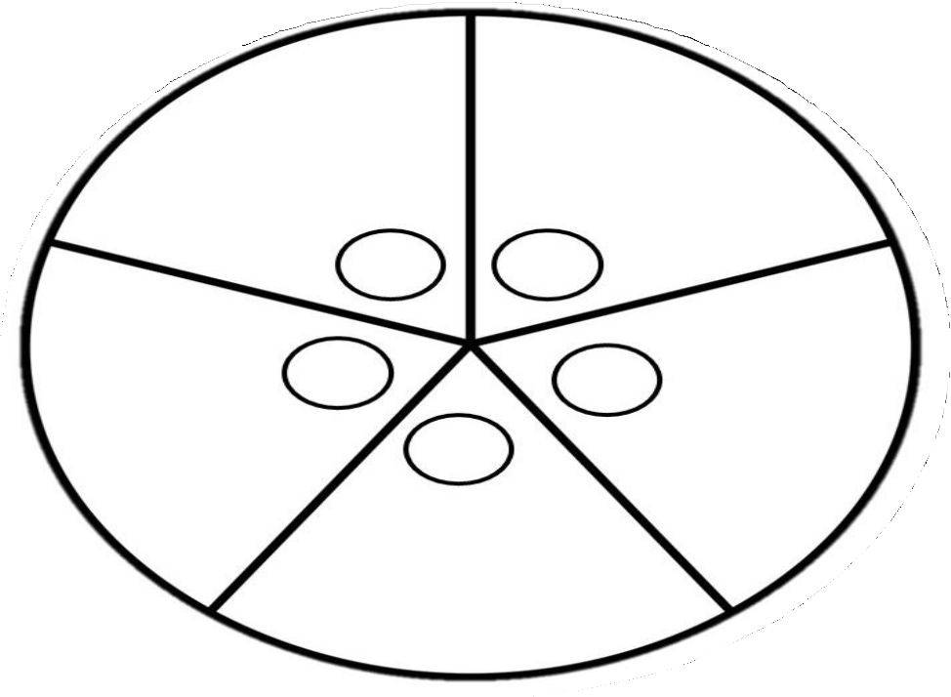

1. Communication in Public
2. Communication with Self
3. Communication between two persons
4. Mass Communication
5. Communication in a small group

3. Delivering your graduation speech to your fellow graduates

2. Cheering yourself up before an important event

4.

Discussing with your groupmate s your assigned report

1. Consoling a friend who is feeling down

5.

Articulating your stand on a pressing issue in the editorial page

# **What is It**

Speech Context is important because it helps you communicate appropriately, understand the meaning of any message conveyed, and respond accordingly. In order for you to have a clear grasp of what Speech Context is, its types are discussed below.

## **Types of Speech Context**

1. **Intrapersonal** – This refers to a type of communication that is focused on one person, where the speaker acts both as the sender and as the receiver of the message. The message is made up of thoughts and feelings while the medium is the brain that processes what you think and feel. (Hybels & Weaver, 2012, p 16)

*Examples:*

* There is a voice within you that tells you, “It’s okay, you can still do it! You can make it!” when you are losing your drive to finish the task that you are doing.
* When you told yourself not to talk to your friends when you have read in a Facebook post that they were in a party and you were not invited.

1. **Interpersonal** – This refers to the type of communication that takes place between and among people and creates a personal relationship between and among them. Normally, it includes two individuals, and it can vary from casual and very personal to formal and impersonal.

### **Types of Interpersonal Communication**

***Dyad Communication*** *–* communication that happens between two people.

*Examples:*

* You consoled your brother who was feeling down.
* A conversation between your father and mother about the latest announcement of your Barangay Chairman.

***Small Group***– This applies to interactions involving at least three but not more than twelve people engaged in face-to-face interactions to achieve the desired goal. In this type of conversation, all participants can freely express their ideas throughout the discussion.

*Examples:*

* You are having a discussion with your two brothers about the surprise party you are planning for your Mom’s birthday.
* Kathlyn who came back from the United States called her three brothers and four sisters and announced that she is getting married.

1. ***Public***– This type refers to a communication that enables you to send or deliver a message before a crowd. The message can be transmitted for informative or persuasive purposes. "In public communication, unlike interpersonal and small groups, the channels are more exaggerated. The voice is louder and the gestures are more expansive because the audience is larger” (Hybels & Weaver, 2012, p 19).

*Examples:*

* Delivering a graduation speech to your fellow graduates.
* You were elected as the new SSG president of your school and were given a chance to deliver a message of gratitude to your fellow students.

1. **Mass Communication** – This refers to communication through television, radio, newspapers, magazines, books, billboards, the internet, and other types of media.

*Examples:*

* You are watching a televised briefing of IATF on COVID-19.
* You have recorded a commentary for your school’s Online Discussion of the pandemic and uploaded it in your social media account.

## **Verbal and Non-verbal Behavior in a Speech Context**

Different speech context whether it is intrapersonal, interpersonal, public or mass communication requires different approaches. Though there might be some occasional similarities, you should at least know how to behave and respond to various speech contexts appropriately.

**When talking to your self**

You might be familiar with the feeling of quietly talking to yourself in your mind, and it's normal — and good for you. By performing this, it makes you think and reflect on the things you have done or are planning to do. But here are some important reminders that you need to keep in mind:



1. ***Use self-talk to your advantage***: Cheering yourself up before an important event or talking to yourself while completing a task are two perfect opportunities for self-talk *(Gould, 2018, Talking to yourself is normal, n.d.).*
2. ***Don’t overdo it***. While it is normal to talk to yourself constantly, it is better not to overuse yourself of doing so. The most common reason why people end up talking to themselves is because they feel like they do not have someone else to talk to. To address this, you need to be more sociable, it would give you more people to talk to other than yourself.

**When talking to one person or a small group of people**

Consoling your friend who is feeling down, or simply talking with your classmates about your plans for a group activity is an example of a dyad and small group communication. This kind of communication implies that the conversation is being shared and there is exchange of ideas. Small group involves different skills because unlike dyad, it consists of more than two people. In both cases, you can be as natural as yourself, however, unlike a running conversation in your head, you have to consider that there are others who are equally important in the conversation. Thus, to achieve successful communication in a dyad or small group, you have to consider the following;

1. 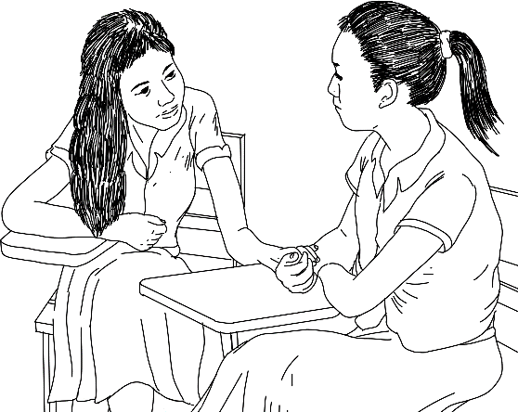***Listen carefully*** - Needless to say, this is the very basic foundation of effective communication. You have to listen carefully and understand what the other person is saying. Asking clarifying questions lets the other person know that you are indeed listening attentively. More so, take active part. You also need to be heard and understood when it is your time to speak.
2. 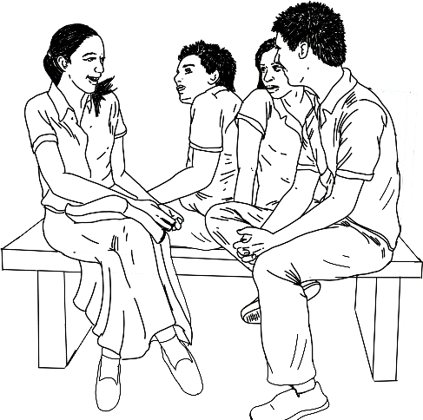***Check your tone and body language* .** The vocabulary of the body is more revealing than the actual words you speak. So, watch your tone and body language while you are talking. Is your tone tough? Do you smile and encourage the person you are talking to? Your body language tells more about your emotions and thoughts than your actual words. Bear this in mind the next time you have a conversation with someone. Check your body language to ensure that it is consistent with your words *(Oakes, 2017).*
3. **When talking to the public**

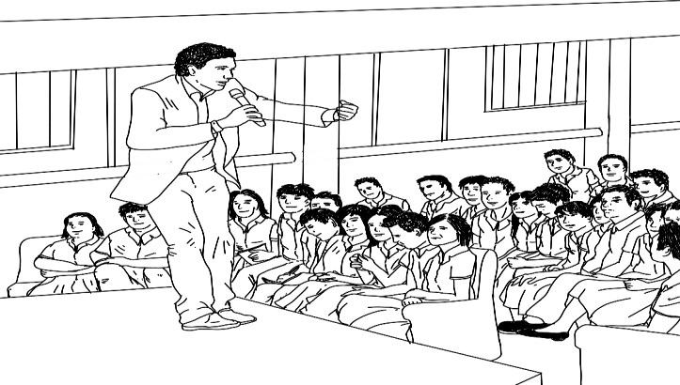Speaking in front of the crowd requires many preparations; from analyzing your target audience, to planning and drafting your speech up to the rehearsing part. The key therefore is to come prepared. Be yourself while you are on stage and speak in the way that you will be easily understood by your audience.

You will know more about this in the succeeding modules about the “Principles of Speech Delivery”.

# **What’s More**

**Crossword Puzzle**

Complete the puzzle below by identifying the four (4) types of Speech Context and the two (2) types of Interpersonal Communication evident in the presented situations.

**ACROSS:**

* 1. Four students are discussing their thesis proposal.

3. Miggy requested his brother Mikko to help him on his task.

6. The city mayor delivered a speech for his townsfolk.

**DOWN:**

2. Webinars for teachers are conducted via Facebook live.

1. The principal interviews a teacher-applicant.
2. Emman talks to himself in front of the mirror.

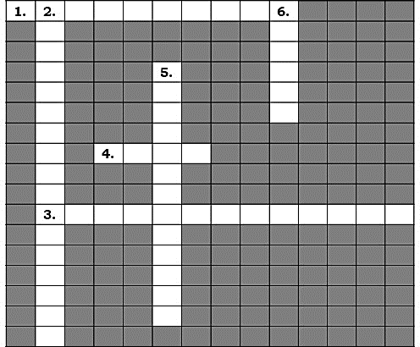

# **What I Have Learned**

1. Based on what you have learned from the previous activities, define speech context in your own words.
2. As a senior high school student, what do you think is the advantage of having good communication skills in a variety of contexts? Do you think it will help you improve your personality? Why or Why not?
3. Do you agree with this statement: Speech context can influence one’s behavior? Why/Why not?
4. Which of the types of speech contexts do you find easy to practice? Which ones do you find difficult?
5. What should you do to improve your skills?

# **What I Can Do**

Using the graphic organizer below, describe each type of speech context and give three (3) examples for each. For the description, refer to the following rubric for evaluating the answer in description.

|  |  |  |
| --- | --- | --- |
| **Type** | **Description** | **Example** |
| Intrapersonal Communication |  | 1.  2.  3. |
| Interpersonal Communication |  | 1.  2.  3. |
| Public Communication |  | 1.  2.  3. |
| Mass Communication |  | 1.  2.  3. |

*Rubric in evaluating the answer in description:*

|  |  |  |  |  |  |
| --- | --- | --- | --- | --- | --- |
| ***CRITERIA*** | ***Points*** | | | | ***SCORE*** |
| ***Completeness*** |  |  |  |  |  |
| *(Did your answer directly describe the type of speech context?)* | *5 points (Excellent)* | *3 points (Very Good)* | *2*  *points (Good)* | *1 point*  *(Needs improvement)* |
| ***Knowledge*** |  |  |  |  |  |
| *(Did your answer clearly show you have read and understand the lesson content by correctly defining the key term?)* | *5 points (Excellent)* | *3 points (Very Good)* | *2*  *points (Good)* | *1 point*  *(Needs improvement)* |
| ***Writing Skills*** |  |  |  |  |  |
| *(Did you write clearly in complete sentence with minimal errors in grammar and spelling?)* | *5 points (Excellent)* | *3 points (Very Good)* | *2*  *points (Good)* | *1 point (Needs*  *improvements)* |

*Adapted from:*

<http://qm.riosalado.edu/resources/SyllabusDB/SocialSciences/Rubric_Short_Answer.pdf>

# **Assessment**

Directions: Choose the letter of the correct answer. Write your answers on a separate sheet of paper.

1. Which of the following is **NOT** a speech context?
   1. Intrapersonal Communication c. Long Distance Communication
   2. Dyad Communication d. Public Communication
2. Which one of the following is **NOT** an example of intrapersonal communication?
   1. sending a text message to a friend c. writing a note to yourself
   2. talking to yourself d. thinking about a problem
3. Which of these is an example of Dyadic Communication?
   1. two brothers arguing
   2. a coach and a player discussing last week’s game
   3. a husband and wife making plans for the summer vacation
   4. all of these are correct
4. Why do you think group communication involves a different set of skills than interpersonal communication? It is because
   1. in a group, one sender has many different receivers to take into account.
   2. in a group, one receiver has many different senders to take into account.
   3. group, by definition, consists more than two people.
   4. group communication is more important than interpersonal communication
5. Which of the following is **NOT** true about speech context?
   1. In public communication, unlike in interpersonal and small group, the channels are more exaggerated. The voice is louder and the gestures are more expansive because the audience is bigger.
   2. The most common reason why people end up talking to themselves is because they feel like they do not have someone else to talk to.
   3. Different speech context whether it is intrapersonal, interpersonal, public or mass communication require different behavior. However, there might be some occasional similarities.
   4. In interpersonal communication, asking clarifying questions lets the other person know that you are not listening attentively.

*For numbers 6-10:*

**Directions**: Identify the type of speech context evident in the following situations.

1. You provided reassuring and comforting words to a friend who was feeling down.
   1. Dyad Communication C. Mass Communication
   2. Public Communication D. Interpersonal Communication
2. You are having a discussion with your group mates on how to finish the assigned task.
   1. Public Communication C. Dyad Communication
   2. Small group communication D. Interpersonal Communication
3. Karen thinks about the things she did the whole day and writes them in her journal.
   1. Intrapersonal C. Mass Communication
   2. Dyad D. Small Group
4. The TV news anchor is giving the latest news update.
   1. Public communication C. Interpersonal Communication
   2. Mass communication D. Intrapersonal Communication
5. Group 5 discussed the effects of social media on communication skills.
   1. Intrapersonal communication C. Mass Communication
   2. Interpersonal communication D. Public Communication

*For numbers 11-15*

**Directions:** Tell whether the given statement is **True** or **False**.

1. In intrapersonal communication, the message is made up of your thoughts and feelings.
2. In small group communication, all participants can freely share ideas in a loose and open discussion.
3. Participating in the declamation, oration, debate or story telling activity is an example of small group communication.
4. To become an effective public speaker, you have to be yourself while you are on stage and speak in the way that you will easily be understood by your audience.
5. Just like in small group communication, the channel in public communication should not be exaggerated.

# **Additional Activities**

Try to recall what you did and how you felt when you experienced any of these situations; (your best friend confided a secret to you; you delivered a speech in front of your classmates as a subject requirement; you talked to yourself about the things you did and what you were supposed to do instead).

What can you say about your experience? What did you learn from it? If you have a second chance, how will you deal with the situations? What examples of verbal and non-verbal responses will you use? Write your answer in a separate sheet of paper.

*Rubric in evaluating the essay*

*Directions:* Your essay will be graded based on this rubric. Consequently, use this rubric as guide in writing your essay and check it again before submitting your final output.

|  |  |  |  |  |
| --- | --- | --- | --- | --- |
| **Criteria** | **5** | **3** | **2** | **1** |
| **Focus and Details** | There is one clear, focused topic.  Main idea is clear and well supported by detailed and  accurate information. | There is one clear, well focused topic. Main idea is clear but not well supported by detailed  information. | Main idea is somewhat clear. | The topic and main idea are not clear. |
|  | The introduction | The | The | There is no |
|  | states the main | introduction | introduction | clear |
|  | topic, and | states the main | states the main | introduction, |
|  | provides an | topic and | topic. A | structure, or |
|  | overview of the | provides an | conclusion is | conclusion. |
| **Organization** | essay. Information | overview of the | included. |  |
|  | is relevant and | essay. A |  |  |
|  | presented in a | conclusion is |  |  |
|  | logical order. The | included. |  |  |
|  | conclusion is |  |  |  |
|  | good. |  |  |  |
|  | It uses vivid words | It uses vivid | It uses words | It uses a limited |
|  | and phrases. The | words and | that | vocabulary. |
|  | choice and | phrases. The | communicate | Jargon or |
|  | placement of | choice and | clearly, but the | clichés may be |
| **Word Choice** | words seems  accurate, natural, | placement of  words is | writing lacks  variety. | present and  detract from the |
|  | and not forced. | inaccurate at |  | meaning. |
|  |  | times and/or |  |  |
|  |  | seems |  |  |
|  |  | overdone. |  |  |
| **Sentence** | All sentences are | Most sentences | Most sentences | Sentences |
| **structure,** | well constructed | are well | are well | sound |
| **grammar** | and have varied | constructed | constructed, | awkward, are |
| **and** | structure and | and have varied | but they have a | distractingly |
| **mechanics** | length. There are | structure and | similar | repetitive or |

|  |  |  |  |  |
| --- | --- | --- | --- | --- |
|  | no errors in | length. There | structure | are difficult to |
| grammar, | are few errors | and/or length. | understand. |
| mechanics, | in grammar, | There are | There are |
| and/or spelling. | mechanics, | several errors in | numerous |
|  | and/or spelling, | grammar, | errors in |
|  | but they do not | mechanics, | grammar, |
|  | interfere with | and/or spelling | mechanics, |
|  | understanding. | that interfere | and/or spelling |
|  |  | with | that interfere |
|  |  | understanding | with |
|  |  |  | understanding. |

Adapted from:

[*http://www.readwritethink.org/files/resources/printouts/Essay%20Rubric.pdf*](http://www.readwritethink.org/files/resources/printouts/Essay%20Rubric.pdf)

What I Know

1. A

2. B

3. C

4. A

5. C

6. D

7.

C

8. B

9.

B

10. D

11. TRUE

12. TRUE

13. FALSE

14. TRUE

15. TRUE

Assessment

What's More

1. Small group

2. Mass

communication

3. Interpersonal

What’s New

1.

C

2. A

1. C

2. B

3. A

3.

D

4. C

5. D

6. A

7. B

8. A

9. B

10. B

11. TRUE

12. TRUE

13. FALSE

14. TRUE

15. FALSE

Dyad

4.

E

4.

5. Intrapersonal

5. D

Public

6.

# **Answer Key**

***References***

DeVito, Joseph A. “Essentials of Human Communication.” Context - The Basics of Human Communication, 2005. https://humancommkj.weebly.com/context.html.

Gould, Wendy Rose. “Go Ahead, Talk to Yourself. It's Normal -and Good for You.” NBCNews.com. NBCUniversal News Group, October 10, 2018. https://[www.nbcnews.com/better/health/talking-yourself-normal-here-s-](http://www.nbcnews.com/better/health/talking-yourself-normal-here-s-) how-master-it-ncna918091.

Hybels, Saundra and Weaver, Richards. Communicating Effectively (10th ed). NY. The McGraw-Hill Companies Inc., 2012.

Learning, Lumen. “Business Communication: Written & Verbal Presentation Skills.” Lumen. Accessed May 28, 2020. https://courses.lumenlearning.com/businesscommunication/?s=context.

Merriam-Webster.com Dictionary, s.v. “context,” accessed May 28, 2020, https://[www.merriam-webster.com/dictionary/context.](http://www.merriam-webster.com/dictionary/context)

Oakes, Tiffany. “6 Tips on Communicating with Others.” E-Learning Industry. eLearning Industry. October 7, 2017. https://elearningindustry.com/communicating-with-others-6-tips.

Solomon Denise and Theiss, Jennifer. *Interpersonal Communication: Putting Theory into Practice*. NY. Routledge, 2013.

Wood, Julia. Communication in Our Lives (Boston, MA: Wadsworth, 1997), 22.

Rubric Sources:

<http://qm.riosalado.edu/resources/SyllabusDB/SocialSciences/Rubric_Short>

_Answer.pdf <http://www.readwritethink.org/files/resources/printouts/Essay%20Rubric.p> df

**For inquiries or feedback, please write or call:**

Department of Education - Bureau of Learning Resources (DepEd-BLR) Ground Floor, Bonifacio Bldg., DepEd Complex

Meralco Avenue, Pasig City, Philippines 1600 Telefax: (632) 8634-1072; 8634-1054; 8631-4985

Email Address: [blr.lrqad@deped.gov.ph](mailto:blr.lrqad@deped.gov.ph) * [blr.lrpd@deped.gov.ph](mailto:blr.lrpd@deped.gov.ph)